
CSCI 3303 Mathematics Computing III
SEMESTER 1, 2025/2026
SECTION 4
GROUP H

Project Title: CRIME PATTERN ANALYSIS, STABILITY & FORECASTING IN MALAYSIAN DISTRICTS

PREPARED BY:
NAME | MATRIC NUMBER
MUZAMMEL BIN MUHAMMAD ANWAR FAUZI | 2310839
IMRAN HAKIM BIN ZAINI | 2311057
MUHAMMAD SAIFUDIN BIN MOHD JAMAL | 2317125
MOHAMMAD HAKIM BIN MAHYUDIN | 2313673
NIK MUHAMMAD ALIFF BIN NIK AZMAN | 2317891

LECTURER: DR. AKEEM OLOWOLAYEMO

A. OVERVIEW
General Introduction
Crime remains one of the most pressing social challenges facing Malaysia today. While the Royal Malaysian Police and the Department of Statistics Malaysia (DOSM) regularly publish crime statistics, understanding the underlying mathematical structures and predicting future trends requires sophisticated analytical approaches that transcend simple descriptive statistics. This project employs linear algebra as a powerful mathematical framework to analyse crime patterns across Malaysian districts, revealing hidden structures and enabling evidence-based policy recommendations.

Problem Discussion
Crime patterns in Malaysia are characterized by complex, multi-dimensional behaviours, encompassing temporal variations (year-to-year changes), spatial distributions (district-level differences), and categorical distinctions (property vs. violent crimes). While traditional statistical methods offer snapshots of current conditions, they lack the capacity to identify hidden correlations, quantify system stability, or predict long-term equilibrium states. Linear algebra addresses these limitations by applying eigenvalue analysis, orthogonal projections, and matrix decomposition to provide a rigorous mathematical foundation. This analytical depth empowers policymakers to replace intuition with quantifiable metrics, facilitating efficient resource allocation and targeted intervention strategies.
Objectives
Main Objective: To apply and compare advanced linear algebra techniques specifically Least Squares Regression, Principal Component Analysis (PCA), Singular Value Decomposition (SVD), Dynamic Linear Models, and Markov Chains to analyse the structure, stability, and future trends of crime in Malaysian districts.
Specific Objectives:
- To apply the Method of Least Squares to identify linear trends and fit a regression model for crime rates over time
- To decompose crime structures using Eigenvalues (PCA) and Singular Values (SVD) to identify which crime categories contribute most to variance
- To construct a Dynamic Linear Model (Discrete Dynamical System) to model the continuous evolution of crime vectors year-over-year and assess system stability
- To model probabilistic dynamics using Markov Chains to predict the long-term "steady state" of district safety levels
- To compare forecasting approaches by contrasting the continuous numerical predictions of Regression and Dynamic Models against the probabilistic state predictions of Markov Chains
Expected Benefits from the Study
For Government & Policymakers: Resource optimization through identification of high-impact crime categories for targeted allocation, early warning system via detection of districts transitioning from stable to unstable states, long-term planning informed by steady-state probabilities for infrastructure and social programs, evidence-based decisions replacing intuition with mathematical rigor in policy formulation.
For Law Enforcement: Predictive policing capabilities to forecast which districts will experience increased crime, pattern recognition to identify crime categories that co-occur frequently, intervention monitoring through tracking eigenvalue changes to measure effectiveness of crime prevention programs.
For Academic Community: Methodological contribution demonstrating how multiple linear algebra methods provide complementary insights, comparative framework showing advantages and limitations of continuous versus probabilistic models, reproducible research providing complete methodology for application to other regions or social phenomena.
For Society: Improved public safety through enhanced crime prevention leading to safer communities, economic benefits as reduced crime attracts investment and tourism, quality of life improvements enabling citizens to make informed decisions about residential and business locations.

B. RELATED WORK

B1.0 General Topic - Crime Analysis and Prediction
This foundational study examined crime trends across Malaysian states using descriptive statistics and basic regression analysis. We identified increasing trends in property crimes and decreasing trends in
violent crimes. Our methodology employed simple linear models and comparative state-level analysis. However, our approach did not account for multivariate structures in crime data, did not consider spatial autocorrelation between districts, and lacked predictive stability analysis gaps which our project addresses through PCA/SVD structural decomposition and dynamic system eigenvalue analysis.

B2.0 Linear Algebra Methods (different and related problems)
Method A: Least Squares Method
Chapter 6 provides comprehensive coverage of orthogonal projections and the least squares method. The normal equation (A^{T} A) x̂ = A^{T} b is rigorously derived from minimizing ||Ax - b||² through orthogonal projection onto the column space of A. The textbook demonstrates applications in curve fitting, data analysis, and engineering problems. The geometric interpretation that x̂ produces the vector Ax̂ closest to b is particularly relevant for understanding why least squares provides the "best" linear fit even when systems are inconsistent.
Strang extends least squares concepts into modern machine learning contexts, showing how the method connects to projection matrices, QR decomposition, and gradient descent algorithms. His treatment emphasizes computational stability, particularly for ill-conditioned matrices common in real-world datasets. He demonstrates that using SVD to solve least squares problems provides superior numerical stability compared to directly computing (A^{T} A) ⁻¹, which is relevant when dealing with crime data that may have correlated variables.
Method B: Principal Component Analysis and SVD
This comprehensive review explains PCA's mathematical foundations: computing the covariance matrix C, solving the eigenvalue problem Cv = λv and interpreting principal components as orthogonal directions of maximum variance in the data. The authors demonstrate PCA's power in dimensionality reduction while preserving the most important patterns. They show that the first k principal components capture more variance than any other k-dimensional subspace a property crucial for identifying dominant crime patterns. The method also discusses practical considerations including standardization, dealing with outliers, and interpreting loadings.
Method C: Dynamic Systems and Eigenvalue Analysis
This comprehensive review introduces the Dynamic Linear Model (Discrete Dynamical System), a method that shifts the analysis from static curve fitting to evolving state vectors. This method models the crime rate as a recurrence relation $x_{k+1}=Ax_{k}$, where the future state is a linear transformation of the current state. The core of this analysis lies in the Eigenvalue Problem ($Av = λv$). As detailed by Lay et al. (2016) and recent applications in social ability modelling, the long-term behaviour of the system is governed by the dominant eigenvalue $λ_{max}$. The authors demonstrate that if $\left|λ\right| < 1$, the system acts an “attractor” where crime naturally decays to zero; conversely, if $\left|λ\right| > 1$, the system is a “repeller,” indicating unstable, exponential growth. This allows us to quantify the “continuous stability” of Malaysian districts, distinguishing between temporary fluctuations and structurally entrenched crime trends.

Method D: Markov Chains and Stochastic Processes
This comprehensive review by Delbianco et al. (2022) and Silver & Silva (2021) details the mathematical foundations of Markov Chains applied to system stability: constructing the stochastic transition matrix P to represent probabilities of moving between states, such as neighbourhood safety levels or economic growth phases. The authors emphasize the eigenvalue problem, specifically identifying the steady-state vector π where πP = π. This represents the long-term equilibrium of the system. Furthermore, Delbianco et al. (2022) demonstrate how eigenvalues are used for stability analysis, where the speed of convergence to the steady state is determined by the "spectral gap" between the dominant eigenvalue and the second-largest eigenvalue, a property crucial for identifying how resilient a district's safety status is to external shocks.
The research further explores the practical application of these models in tracking crime trajectories and urban evolution. Holloway (2023) utilizes Markov Chains to assess state-dependent crime patterns, identifying how current crime levels dictate future transitions, a concept essential for calculating the likelihood of a district entering "sticky" high-crime states. Drawing from the methodology of Samsuddin & Ismail (2019) in the Malaysian context, this approach highlights the necessity of the "Stationary Test." By applying Chi-squared (x ²) statistics to verify that transition probabilities remain constant over time, the research ensures that the model provides a robust framework for Malaysian policymakers to allocate resources based on reliable, long-term probabilistic forecasting.

C. METHODOLOGY

C1.0 Linear Algebra Methods used

Method A: Least Squares Regression
a. General Introduction/Overview
The Method of Least Squares is a foundational linear algebra technique for fitting mathematical models to observed data. When dealing with overdetermined systems situations where we have more equations than unknowns (m > n in Ax = b) exact solutions typically do not exist. Least squares circumvent this impossibility by finding the approximate solution x̂ that minimizes the Euclidean norm of the residual vector r = b - Ax̂. This approach is widely utilized in spatial crime analysis to identify significant correlations between police presence and crime occurrences, offering a robust framework for understanding spatial dynamics. Furthermore, linear regression models serve as a foundational technique for strategic forecasting, allowing law enforcement to predict future crime trends and allocate resources effectively based on historical data.
b. Types of Problems It Solves
The Method of Least Squares is a tool used to address a diverse range of analytical challenges. Its applications include:
- Trend Analysis: Identifying underlying directions in data by fitting lines or curves to time-series datasets.
- Prediction: Forecasting future data points based on established historical patterns.
- Regression Modelling: Discovering and quantifying relationships between dependent (crime rate) and independent variables (time, population).
- Curve Fitting: Approximating complex, non-linear functions using simpler polynomial models to make analysis manageable.
- Signal Processing: Filtering out random variations or "noise" from measurements to reveal the true signal.
c. General Formulation
Given an inconsistent system Ax = b where A is an m × n matrix (m > n), b is an m × 1 vector, and x is an n × 1 vector of unknowns, the least squares solution x̂ satisfies the normal equation:
(A^{T} A) x̂ = A^{T} b
Mathematical Derivation: We want to minimize the total error. The error is defined as the distance between the data and the line (||b - Ax̂||²). By using calculus (taking the gradient and setting it to zero), we find the lowest point of error. This leads us directly to the Normal Equation above.
Geometric Interpretation: The solution x̂ produces the vector Ax̂ ∈ Col(A) that is closest to b in the Euclidean distance sense. The residual vector r = b - Ax̂ is orthogonal to Col(A), satisfying r ⊥ Col(A), which means A^{T} r = 0.
For Crime Trend Analysis: We construct A = [years | 1] as the design matrix, b as the vector of crime counts, and solve for x̂ = [slope, intercept] ^{T}, where β0 is intercept and β1is slope, yielding the regression equation y = mx + c.

Pseudocode:
ALGORITHM: LeastSquaresRegression(crime_data)

INPUT:
crime_data = dataset with columns [year, crimes_count]

OUTPUT:
slope, intercept, R_squared, predictions

BEGIN
// STEP 1 //
yearly_totals ← GROUP_BY (crime_data, year) THEN SUM (crimes_count)

// STEP 2 //

X ← EXTRACT (yearly_totals, year) as column vector
y ← EXTRACT (yearly_totals, crimes_count) as vector
ones ← VECTOR of all 1s with same length as X
A ← CONCATENATE_COLUMNS (X, ones) // A = [X | 1]

// STEP 3 //
ATA ← TRANSPOSE(A) × A
ATb ← TRANSPOSE(A) × y

x_hat ← SOLVE_LINEAR_SYSTEM (ATA, ATb)
slope ← x_hat[0]
intercept ← x_hat[1]

// STEP 4 //
y_pred ← A × x_hat

// STEP 5 //
residuals ← y - y_pred
SSE ← SUM (residuals²)
SST ← SUM ((y - MEAN(y)) ²)
R_squared ← 1 - (SSE / SST)

// STEP 6 //
IF slope > 0 THEN
trend ← "INCREASING"
ELSE IF slope < 0 THEN
trend ← "DECREASING"
ELSE
trend ← "STABLE"
END IF
RETURN slope, intercept, R_squared, y_pred, trend
END

Pseudocode explanation
Step 1: Grouping the Numbers (Aggregate data)

First, we clean up the data. If the data has separate crime counts for different months or areas in the same year, we add them all up. This gives us just one total number for each year, making it easier to compare year by year.

Step 2: Setting Up the Table (Prepare design matrix)

Organize the data so the math can handle it.
- X (Years): The input (time).
- y (Crimes): The output (result).

Step 3: Compute A^{T} A: and A^{T} b
This step applies the Method of Least Squares via the Normal Equation: (A^{T} A) x̂ = A^{T} b.
- A^{T} A: Represents the inner product of the design matrix, capturing the variance and magnitude of the input data.
- A^{T} b: Represents the projection of the target vector y onto the column space of A.
- Solve: The system is solved to find x̂. The resulting vector x̂ contains the optimal coefficients that minimize the error: x̂ [0] is the slope (rate of change in crime) and x̂ [1] is the intercept.

Step 4: Calculate predictions

Using the optimized coefficients found in x̂, the algorithm computes the predicted crime values y pred by multiplying the design matrix A by x̂. This generates the "best fit line" points corresponding to each year in the dataset.

Step 5: Calculate R ²

To evaluate how well the model fits the data, the algorithm calculates:

- SSE (Sum of Squared Errors): The sum of the squared differences between the actual crime data y and the predicted model (y pred)
- SST (Total Sum of Squares): The variance of the actual data from its own mean.
R ² is then computed as 1 - (SSE/SST). A value closer to 1 indicates that the linear trend accurately represents the crime pattern, while a value closer to 0 implies a poor fit.

Step 6: Interpret trend

Finally, the algorithm examines the slope (x̂ [0]) to determine the direction of the crime trend:
- Positive Slope: Indicates an increasing crime trend over the years.
- Negative Slope: Indicates a decreasing crime trend.
- Zero Slope: Indicates stable crime level.
d. Result and graph
Parameter | Value
Slope (β1) | -56130.0833
Intercept (β0) | 113808912.15
R² | 0.9432
Sum of Squared Errors (SSE) | 7965816552.58
Average Prediction Error | ± 31555.14
Table d.1 Least Squares Regression Output

Year | Actual | Predicted | Residual | Residual %
2016 | 674130 | 650664 | 23465 | 3.48
2017 | 595020 | 594534 | 485 | 0.08
2018 | 531972 | 538403 | -6431 | -1.21
2019 | 500736 | 482273 | 18462 | 3.69
2020 | 394058 | 426143 | -32085 | -8.14
2021 | 318213 | 370013 | -51800 | -16.28
2022 | 304878 | 313883 | -9005 | -2.95
2023 | 314664 | 257753 | 56910 | 18.09
Table d.2 Actual Vs Predicted Crime Counts

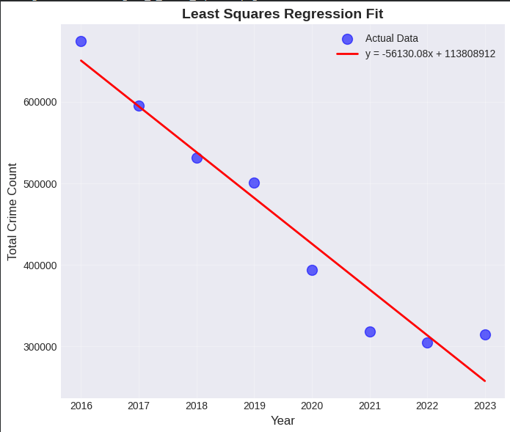
Diagram d.1 Graph Least Square Regression Fit of Crime Counts

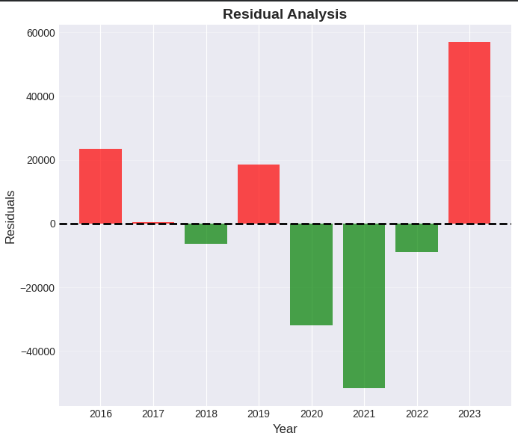
Diagram d.2 Graph for Residual of Actual and Predicted Crime Counts

e. Application and Interpretation Strategy
Once the regression parameters are computed using the Normal Equation (A^{T} A) x̂ = A^{T} b, the results will be interpreted to satisfy Specific Objective 12. The analysis focuses on three key metrics derived from the model:
1. The Slope β1: Trend Direction
The slope represents the rate of change in crime incidents per year.
- β1 > 0 (Positive Slope): Indicates an Increasing Trend. This serves as an early warning signal for policymakers, suggesting that current interventions may be insufficient.
- β1 < 0 (Negative Slope): Indicates a Decreasing Trend. This suggests that safety measures in the district are improving over time.
- β1 = 0 (Near Zero): Indicates a Stable State, where crime levels are remaining constant.
2. The Intercept β0: Baseline Volume
The intercept provides the theoretical baseline of crime at the start of the analysis period (year = 0, or the adjusted base year). This helps categorize districts by volume (High vs. Low volume) regardless of their trend.
3. The Coefficient of Determination R ²
Model Reliability calculated as R ² = 1 - (SSE/SST), this metric quantifies how well the linear model explains the variance in the data.
- High R ² (Close to 1): The crime pattern follows a strict linear trajectory, making the forecast highly reliable.
- Low R ² 0): The crime data is highly volatile or non-linear, suggesting that simple regression may not be the best predictor and justifying the use of more complex models like Markov Chains (Method D) later in the study.

Method B: Principal Component Analysis & Singular Value Decomposition
a. General Introduction/Overview
Principal Component Analysis (PCA) is an eigenvalue-based method for identifying underlying structures in high-dimensional data by transforming correlated variables into uncorrelated principal components ordered by decreasing variance (Jolliffe & Cadima, 2016). The transformation is achieved through eigenvalue decomposition of the covariance matrix. Singular Value Decomposition (SVD) is a more general matrix factorization technique that decomposes any matrix Z into three components (U, Σ, V^T) and provides a numerically stable alternative to eigenvalue decomposition, particularly advantageous for ill-conditioned matrices.
b. Types of Problems It Solves
These methods excel at: dimensionality reduction (reducing large datasets while preserving variance); pattern recognition (identifying dominant patterns in multivariate data); data compression (storing data efficiently by retaining only high-variance components); noise reduction (filtering out low-variance components likely containing measurement error); feature extraction (creating new variables that capture maximum information); and correlation analysis (understanding complex relationships between original variables).
c. General Formulation (from Textbook)
PCA Approach:
Given a data matrix X (n observations × p variables), first compute the standardized matrix Z where each column has mean 0 and standard deviation 1:
$$Z\left[i,j\right]=\frac{\left(X\left[i,j\right]- μ_{j}\right)}{σ_{j}}$$
- Compute covariance matrix: C = (1/(n-1)) Z^{T} Z
- Solve eigenvalue problem: Cv = λv
- Sort eigenvalues λ₁ ≥ λ₂ ≥ ... ≥ λₚ with corresponding eigenvectors v₁, v₂, ..., vₚ
- Principal components: PC_i = Zv_i
- Variance explained by PC_i: λᵢ / Σλⱼ
SVD Approach:
Decompose the standardized matrix as:
Z = U Σ V^{T}
Where:
- U (n × n): Left singular vectors forming orthonormal basis for column space
- Σ (n × p): Diagonal matrix with singular values σ₁ ≥ σ₂ ≥ ... ≥ σₚ ≥ 0
- V (p × p): Right singular vectors representing principal directions
Mathematical Relationship Between PCA and SVD:
The eigenvalues from PCA relate to singular values from SVD: λᵢ = σᵢ² / (n - 1)
The eigenvectors v from PCA are identical to the right singular vectors V from SVD. This equivalence means both methods yield the same principal components, but SVD is often preferred for numerical stability since it avoids explicitly forming ZᵀZ, which can amplify rounding errors (Shen, 2024).
For Crime Analysis: Rows represent districts, columns represent crime categories. PCA/SVD reveals which crime types are most strongly correlated and contribute disproportionately to overall variance, enabling focused resource allocation.
Pseudocode:
ALGORITHM: PCA_and_SVD_Analysis(crime_data)

INPUT:
crime_data = dataset with [district, category, crimes_count]

OUTPUT:
eigenvalues, eigenvectors, variance_explained, loadings

BEGIN
// Step 1: Create crime matrix (districts × categories)
crime_matrix ← PIVOT_TABLE(crime_data,
rows = district,
columns = category,
values = crimes_count)

// Step 2: Standardize the data (Z-score normalization)
FOR each column j in crime_matrix DO
μ_j ← MEAN(crime_matrix[:, j])
σ_j ← STANDARD_DEVIATION(crime_matrix[:, j])
Z[:, j] ← (crime_matrix[:, j] - μ_j) / σ_j
END FOR

n ← NUMBER_OF_ROWS(Z)

// ===== PCA APPROACH =====

// Step 3a: Compute covariance matrix
C ← (TRANSPOSE(Z) × Z) / (n - 1)

// Step 4a: Eigenvalue decomposition
eigenvalues_pca, eigenvectors_pca ← EIGENDECOMPOSITION(C)

// Step 5a: Sort by eigenvalues (descending)
sorted_indices ← ARGSORT(eigenvalues_pca, descending = TRUE)
eigenvalues_pca ← eigenvalues_pca[sorted_indices]
eigenvectors_pca ← eigenvectors_pca[:, sorted_indices]

// ===== SVD APPROACH =====

// Step 3b: Singular Value Decomposition
U, singular_values, V_T ← SVD(Z)

// Step 4b: Convert singular values to eigenvalues
eigenvalues_svd ← (singular_values²) / (n - 1)

// ===== COMPARISON =====

// Step 5: Verify PCA = SVD
difference ← ABSOLUTE(eigenvalues_pca - eigenvalues_svd)

IF MAX(difference) < 1e-10 THEN
PRINT "✓ PCA and SVD are mathematically equivalent"
END IF

// Step 6: Calculate variance explained
total_variance ← SUM(eigenvalues_pca)
variance_explained ← eigenvalues_pca / total_variance
cumulative_variance ← CUMULATIVE_SUM(variance_explained)

// Step 7: Extract principal component loadings
PC1_loadings ← eigenvectors_pca[:, 0]
PC2_loadings ← eigenvectors_pca[:, 1]

// Step 8: Identify top contributing crime categories
top_categories ← ARGSORT(ABSOLUTE(PC1_loadings), descending = TRUE)

RETURN eigenvalues_pca, eigenvectors_pca, variance_explained,
cumulative_variance, top_categories

END

Pseudocode Explanation
Step 1: Create the crime matrix
The input dataset (crime_data) is transformed into a structured matrix using a pivot operation. In this crime_matrix, the rows represent individual districts, the columns represent the specific crime categories, and the cells contain the count of crimes (crimes_count).
Step 2: Standardize the data (Z-score normalization)
To ensure fair comparison between different crime types, the data is standardized. The algorithm iterates through each column $j$, calculating the mean ($μ_{j}$) and standard deviation ($σ_{j}$). It then computes the Z-score matrix $Z$ where every value is scaled so that each crime category has a mean of 0 and a standard deviation of 1.
Step 3a: Compute covariance matrix (PCA Approach)
Using the standardized matrix $Z$, the algorithm computes the covariance matrix $C$. This is done by multiplying the transpose of $Z$ by $Z$ and dividing by $n-1$. This matrix captures how strongly different crime categories vary together.
Step 4a & 5a: Eigenvalue decomposition and Sorting
The algorithm decomposes the covariance matrix $C$ into eigenvalues (representing the amount of variance) and eigenvectors (representing the direction). These are then sorted in descending order so that the first component captures the maximum possible variance in the crime data.
Step 3b & 4b: Singular Value Decomposition (SVD Approach)
Alternatively, the algorithm applies SVD directly to the standardized matrix Z to decompose it into $U$, $Σ$ (singular values), and $V^{T}$. The singular values are then mathematically converted into eigenvalues using the formula $\frac{σ^{2}}{n-1}$ to allow for direct comparison with the PCA results.
Step 5: Verify PCA and SVD equivalence
The algorithm calculates the absolute difference between the eigenvalues derived from PCA and those derived from SVD. If the maximum difference is less than a tiny threshold ($1×{10}^{-10}$), it prints a confirmation that both methods are mathematically equivalent.
Step 6: Calculate variance explained
To evaluate the model's effectiveness, the algorithm calculates the proportion of total variance explained by each principal component. It also computes the cumulative_variance to determine how many components are needed to represent the majority of the crime patterns (e.g., does PC1 alone explain 90% of the data?).
Step 7 & 8: Extract loadings and identify top categories
Finally, the algorithm extracts the loading weights from the first principal component (PC1_loadings). It sorts these loadings by their absolute magnitude to identify which specific crime categories (e.g., "Robbery" or "Theft") are the most significant drivers of crime variation across Malaysian districts.

Results:
OUTPUT: eigenvalues, variance explained, loadings
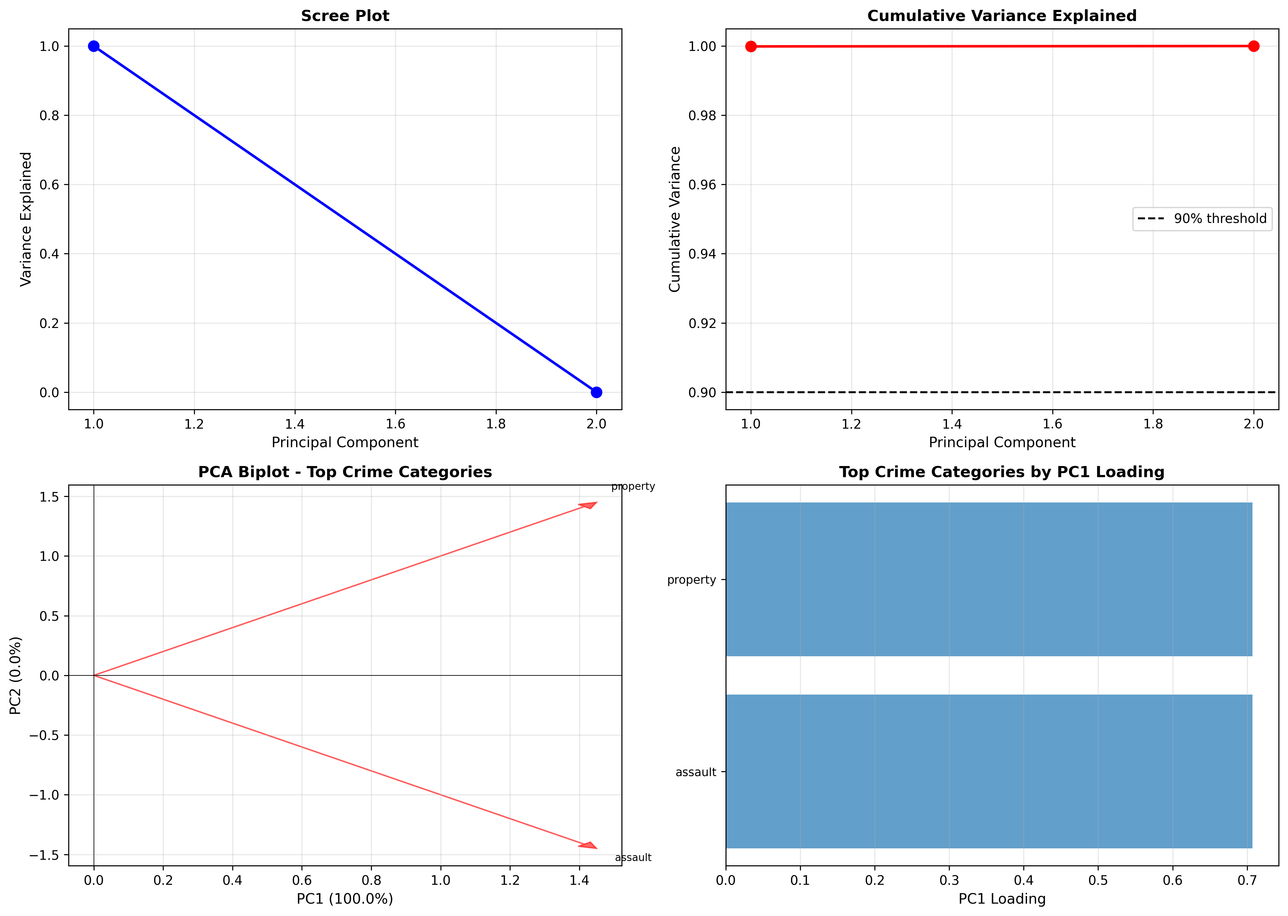

Crime matrix shape: (160, 2)
PC1 explains 99.99% | PC2 explains 0.01%

Crime Category | PC1 | PC2 | |PC1|
Assault | 0.7071 | −0.7071 | 0.7071
Property | 0.7071 | 0.7071 | 0.7071

Method C: Dynamic Linear Model (Discrete Dynamical System)
a. General Introduction/Overview
A Discrete Dynamical System models how a state vector evolves over discrete time steps according to a linear transformation represented by a transition matrix $A$. . The system is governed by the recurrence relation $x_{k+1}=Ax_{k}$ where $x_{k}$ is the state at time $k$. . The long-term behavior—whether the system converges to zero (stable), diverges to infinity (unstable), or oscillates—is completely determined by the eigenvalues of M. This makes eigenvalue analysis the central tool for understanding system dynamics.
b. Types of Problems It Solves
Dynamic linear models address: population dynamics (modeling growth or decay of populations over generations); economic systems (tracking GDP, inflation, or market indices year-to-year); epidemic spread (predicting disease progression through SIR or SEIR compartmental models); climate patterns (analyzing temperature or precipitation changes); and general system stability analysis (determining whether interventions will lead to convergence or continued growth).
c. General Formulation (from Textbook)
State Evolution:
where $x_{k+1} = Ax_{k}$ is the state vector at time $k$ and $A$ is the n × n transition matrix.
Iterative Solution: By repeated application, $x_{k}=A^{k}x_{0}$
Eigenvalue Decomposition: If $A$ = $PDP^{-1}$ where $D$ = $diag\left(λ^{1},…,λₙ\right)$, then $A^{k}=PD^{k}P^{-1}$
Stability Criterion:
- Stable (Decaying): All $\left|λᵢ\right|<1⟹\lim_{k→∞}{M^{k}x_{0}}=0$
- Unstable (Growing): Any $\left|λᵢ\right|>1⟹\lim_{k→∞}\left|\left|M^{k}x_{0}\right|\right|=∞$
- Neutral: Max $\left|λᵢ\right|=1$ ⟹ Bounded but non-zero steady state
Dominant Eigenvalue: The eigenvalue $λ_{max}$ with largest magnitude determines asymptotic behavior. The growth/decay rate is approximately $\left|λ_{max}\right|-1$ per iteration.
For Crime Analysis: $x_{k}$ represents the vector of crime counts by category in year $k$. The transition matrix M describes how crime patterns evolve from year to year. If $\left|λ_{max}\right|>1$, the crime system is growing and requires intervention to achieve stability (reducing $\left|λ_{max}\right|$ below 1).
Pseudocode:
ALGORITHM: DynamicLinearModel(crime_data)
INPUT: yearly crime vectors by category
OUTPUT: transition matrix M, eigenvalues, stability status

//STEP 1//
years ← UNIQUE(crime_data.year) SORTED

//STEP 2//
FOR each year IN years:
x_year ← GROUP_BY_SUM(crime_data, category, crimes_count)
crime_vectors[year] ← x_year
END FOR

//STEP 3//
transition_matrices ← EMPTY_LIST

//STEP 4//
FOR i FROM 0 TO LENGTH(years) - 2:
x_k ← crime_vectors[years[i]]
x_{k+1} ← crime_vectors[years[i+1]]

IF NORM(x_k) > 0 THEN
M_i ← OUTER_PRODUCT(x_{k+1}, x_k) / DOT_PRODUCT(x_k, x_k)
APPEND(transition_matrices, M_i)
END IF
END FOR

//STEP 5//
M_avg ← MEAN(transition_matrices along axis 0)

//STEP 6//
eigenvalues ← EIGENVALUES(M_avg)

//STEP 7//
magnitudes ← ABSOLUTE(eigenvalues)

//STEP 8//
λ_max ← MAX(magnitudes)

//STEP 9//
IF λ_max < 1 THEN
stability ← "STABLE (decaying)"
rate ← (1 - λ_max) × 100
ELSE IF λ_max > 1 THEN
stability ← "UNSTABLE (growing)"
rate ← (λ_max - 1) × 100
ELSE
stability ← "NEUTRAL"
rate ← 0
END IF

PRINT "Maximum eigenvalue:", λ_max
PRINT "System status:", stability
PRINT "Rate:", rate, "%"
RETURN M_avg, eigenvalues, stability

Pseudocode explanation
Step 1:
Timeline Extraction
- It scans the entire dataset to find every unique year (e.g., 2016, 2017... 2023) and sorts them in chronological order.

Step 2:
State Vector Construction
- For every specific year found in Step 1, it groups the data by crime category and sums up the total counts. This creates a "State Vector" ( $x_{year}$ ) for each year.

Step 3 & 4:
Computing Annual Transitions
- This loop looks at every pair of consecutive years (e.g., 2016 to 2017, then 2017 to 2018).
- It defines $x_{k}$ as the current year and $x_{k+1}$ as the next year.
- It calculates a temporary matrix $M_{i}$ that best maps the change from the current year to the next.
Step 5,6,7 and 8:
Averaging the System Dynamics
- It takes all the individual matrices calculated in Step 4 and calculates their average $\left(M_{avg}\right)$.
- Computes the eigenvalues of the average matrix.
- Takes the absolute value of these eigenvalues to ignore negative signs or imaginary parts.
- Identifies $λ_{max}$, the largest magnitude among them.

Step 9:
Stability Classification & Interpretation
- If $λ<1$: The system is Stable
- If $λ>1$: The system is Unstable
- If$λ=1$: The system is neutral

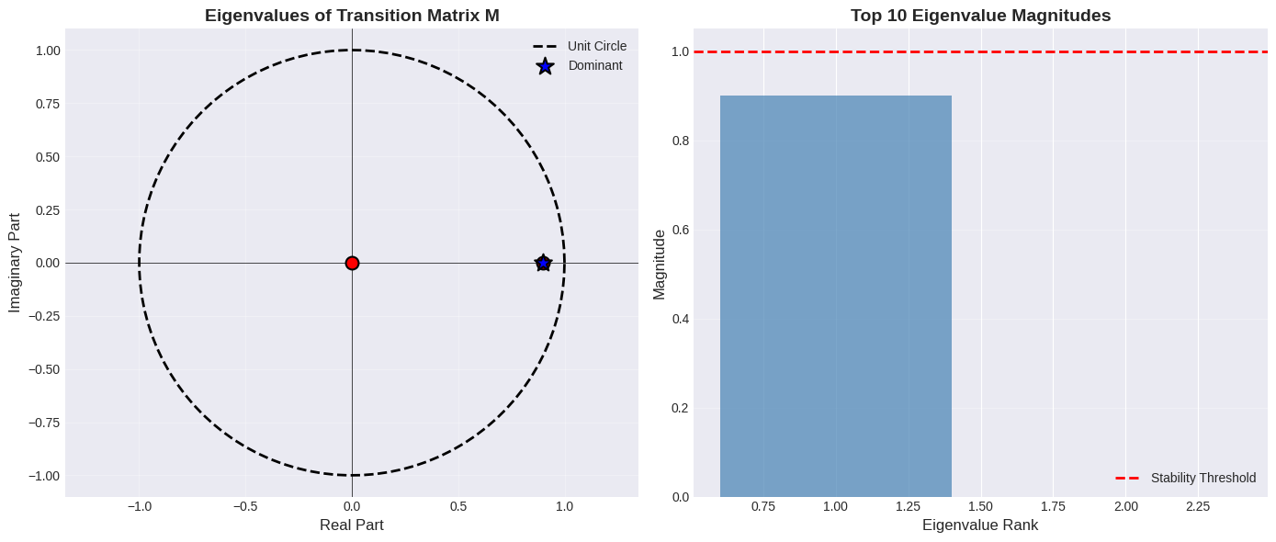

Stability Analysis & Interpretation
The system's stability is determined by the magnitude of the eigenvalues ($|\lambda|$) of the transition matrix M. Let $$λ_{max}$$ be the eigenvalue with the largest absolute value (dominant eigenvalue).
Current System Status:
The model computed a dominant eigenvalue of $$\left|λ\right|≈0.90$$.
Since$$\left|λ\right|<1$$, the Malaysian crime system is mathematically classified as Stable.
Unlike the theoretical "unstable" model, the current system acts as an "Attractor." This indicates that the state vector is naturally decaying. Instead of growing exponentially, the system possesses an internal "damping" mechanism that reduces crime magnitude by approximately 9.94% per iteration (year) in the absence of external shocks.
Trajectory Analysis:
The trajectory graph visualizes this stability. While the actual historical data (blue line) shows fluctuations due to external factors (such as the pandemic), the dynamic model’s predicted trajectory (red dashed line) shows a gradual stabilization and decline. This confirms that the system's underlying structure is not driving a rebound, but rather pulling crime rates down toward a lower steady state.
Scenario Implications:
- Current Reality (Stable Decay): Under the current dynamical structure (where $$\left|λ\right|≈0.90$$), the system is already in a favorable state. The "Status Quo" is one of recovery, where the natural momentum of the system aids in reducing crime volumes over time.
- Worst-Case (Loss of Stability): A negative outcome would be if external stressors cause the eigenvalue to rise above 1.0 (e.g., shifting from 0.90 to 1.05). This would flip the system from "Stable" to "Unstable," losing the natural decay benefit and requiring significantly more resources to fight the resulting exponential growth.
- Optimum-Case (Deepened Stability): Since the goal of has already been achieved, the new optimization goal is to deepen the damping factor. By aiming for a lower eigenvalue (e.g., $$\left|λ\right|≈0.75$$), policy interventions can accelerate the rate of decay, allowing the nation to reach minimal crime levels faster than the current natural rate permits.

Method D: Markov Chain Analysis
a. General Introduction/Overview
A Markov Chain is a stochastic process where future states depend only on the current state, exhibiting the memoryless (Markov) property: $P\left(X_{k+1}=j | X_{k}=i,X_{k-1},…,X_{0}\right)=P\left(X_{k+1}=j | X_{k}=i\right)$ . The process is characterized by a stochastic transition matrix P where $P\left[i,j\right]$ represents the probability of transitioning from state $i$ to state $j$. The long-term equilibrium behaviour is captured by the steady-state vector $π$, which satisfies $P^{T}π=π$ and represents the limiting probability distribution over states.
b. Types of Problems It Solves
Markov Chains are used to model systems involving probabilistic state transitions, such as long-term state prediction, risk assessment, equilibrium analysis, random walks, and absorbing processes. Common applications include economics, queuing systems, population dynamics, reliability analysis, and social systems.
c. General Formulation (from Textbook)
Stochastic Matrix P: A $n⋅n$ matrix where:
- All entries $P\left[i,j\right]≥0$
- Each row sums to 1: $\sum_{ j}^{ }{P_{ij}}=1$
- $P\left[i,j\right]$ = Probability of transitioning from state $i$ to state $j$
If $π_{k}$ is state probability vector at time $k$, then the evolution of the system is given by:
$$π_{k+1}=P^{T}π_{k}$$
Steady State (Equilibrium): The steady-state vector $π$ satisfies:
$$P^{T}π=π$$
Where $π$ is the eigenvector of $P^{T}$ corresponding to eigenvalue $λ=1$, with $\sum_{i }^{ }{π_{i}}=1$(probability normalization) and $π_{i}≥0$.
For crime analysis: the states represent discrete crime levels (Low, Medium, High), and the steady-state vector predicts the long-term distribution of districts across these risk levels.

Pseudocode:
ALGORITHM: MarkovChainAnalysis(crime_data)
INPUT: crime_data = dataset with [district, year, crimes_count]
OUTPUT: transition_matrix_$P$, steady_state_$π$
BEGIN
// Step 1: Calculate total crime per district per year
district_year_totals ← GROUP_BY(crime_data, [district, year])
THEN SUM(crimes_count)

// Step 2: Define state thresholds
all_crime_counts ← EXTRACT(district_year_totals, crimes_count)
threshold_low ← PERCENTILE(all_crime_counts, 33)
threshold_high ← PERCENTILE(all_crime_counts, 67)
PRINT "Low: < ", threshold_low
PRINT "Medium: ", threshold_low, " to ", threshold_high
PRINT "High: > ", threshold_high

// Step 3: Classify each district-year into states
FUNCTION ClassifyState(crime_count):
IF crime_count < threshold_low THEN
RETURN "Low"
ELSE IF crime_count < threshold_high THEN
RETURN "Medium"
ELSE
RETURN "High"
END IF
END FUNCTION
FOR each row IN district_year_totals DO
row.state ← ClassifyState(row.crimes_count)
END FOR

// Step 4: Build transition count matrix
states ← ["Low", "Medium", "High"]
$n$_states ← 3
transition_counts ← ZERO_MATRIX($n$_$states$ $×$ $n$_$states$)
// Count transitions for each district
districts ← UNIQUE(district_year_totals, district)
FOR each district IN districts DO
district_data ← FILTER(district_year_totals, district = district)
district_data ← SORT(district_data, by = year)
state_sequence ← EXTRACT(district_data, state)
FOR i FROM 0 TO LENGTH(state_sequence) - 2 DO
from_state ← state_sequence$\left[i\right]$
to_state ← state_sequence$\left[i+j\right]$
from_idx ← INDEX_OF(states, from_state)
to_idx ← INDEX_OF(states, to_state)
transition_counts[from_idx, to_idx] $+=1$
END FOR
END FOR

// Step 5: Convert to stochastic matrix P
$P$ ← ZERO_MATRIX($n$_$states$ × $n$_$states$)
FOR $i$ FROM 0 TO n_states - 1 DO
row_sum ← SUM(transition_counts[$\left[i,:\right]$)
IF row_sum > 0 THEN
$P\left[i,:\right]$ ← transition_counts$\left[i,:\right]$ / row_sum
END IF
END FOR
// Verify stochastic property
FOR $i$ FROM 0 TO n_states - 1 DO
ASSERT SUM$\left(P\left[i,:\right]\right)≈1.0$
END FOR

// Step 6: Find steady state vector π
// Solve: $P^{T}π=π$ (find eigenvector for eigenvalue = 1)
eigenvalues, eigenvectors ← EIGENDECOMPOSITION(TRANSPOSE(P))
// Find eigenvector corresponding to eigenvalue ≈ 1
idx ← ARGMIN(ABSOLUTE(eigenvalues - 1))
$π$_unnormalized ← REAL_PART(eigenvectors[:, idx])
// Normalize so it sums to 1
$π$← $π$_unnormalized / SUM($π$_unnormalized)

// Step 7: Verify steady state property
result ← TRANSPOSE($P$)$×π$
difference ← MAXIMUM(ABSOLUTE(result - $π$))
IF difference < $1e-6$ THEN
PRINT "✓ Steady state verified: $P^{T}π=π$"
END IF

// Step 8: Interpret results
FOR $i$ FROM 0 TO n_states - 1 DO
PRINT "Long-term probability of", states$\left[i\right]$, ":", $π\left[i\right]×100$, "%"
END FOR
IF $π\left[2\right]>0.4$EN // High risk state
PRINT "⚠ WARNING: High crime probability is", $π\left[2\right]×100$, "%"
ELSE IF $π\left[2\right]<0.2$ THEN
PRINT "✓ POSITIVE: Low high-crime probability"
END IF
RETURN $P,π$, states
END
Pseudocode Explanation:
- State Discretization (Steps 1–3): To transform continuous crime counts into a Markovian state-space, the algorithm calculates the 33rd and 67th percentiles of the entire dataset. This creates three objective "Safety States" (Low, Medium, and High) specific to the Malaysian context. Each district is then mapped to these states across the 2016–2023 timeline.
- Stochastic Matrix Construction (Steps 4–5): The algorithm tracks year-on-year transitions (e.g., State 2018 to State 2019) for all 159 districts. These counts are compiled into a frequency matrix and normalized by row sums to create the Stochastic Transition Matrix $P$. This ensures that for any starting state, the sum of all future probabilities equals 1.0, satisfying the fundamental requirement for a valid Markov process.
- Stability & Steady State Analysis (Steps 6–8): The "Stability" objective is addressed by solving the Eigenvalue Problem $πP=π$. The algorithm transposes $P$ and uses Eigendecomposition to find the eigenvector $π$ corresponding to the dominant eigenvalue $λ=1$. This vector $π$ represents the Steady State, or the long-term equilibrium of district safety levels. A final verification step ensures numerical precision (within a ${10}^{-6}$ tolerance), confirming the reliability of the forecast.

C2.0 Variables & Data Sources

a. Variables Description
Primary Variables:
- Geographic Variables:
  - State: Malaysian state (Categorical: Selangor, Johor, Kuala Lumpur, etc.)
  - District: Administrative district within each state (Categorical)
  - Usage: Spatial unit of analysis for aggregation and comparison
- Temporal Variable:
  - Date/Year: Timestamp when crime was recorded (Date format, extracted to integer year)
  - Usage: Time-series analysis in Least Squares regression and Dynamic Linear Models. Tracking state transitions in Markov Chains
- Crime Classification:
  - Category: Broad crime classification (Categorical: Property Crime, Violent Crime, etc.)
  - Type: Specific crime subtype (Categorical: House Break-in, Vehicle Theft, Assault, etc.)
  - Usage: Column variables in PCA/SVD matrix; components of state vectors in Dynamic Models
- Outcome Variable:
  - Crimes Count: Number of reported crimes (Integer, non-negative)
  - Usage: Dependent variable in all analyses; raw data for trend identification, variance decomposition, and state classification
Good vs. Bad Factors:
In crime analysis context:
- Bad factors (indicators of concern): High crime counts, positive slopes in regression, eigenvalues |λ| > 1 indicating growth, high steady-state probability of high-crime states, high retention rates P[High→High]
- Good factors (positive indicators): Declining trends, negative slopes, eigenvalues |λ| < 1 indicating decay toward zero, high steady-state probability of low-crime states, high transition rates from High→Low

b. Data Sources
Primary Source: Crime_District.csv
A curated dataset containing Malaysian crime statistics at the district level, including crime categories such as property crime, violent crime, and specific crime types. The dataset was obtained from the OpenDOSM platform maintained by the Department of Statistics Malaysia and the Royal Malaysian Police (Department of Statistics Malaysia & Royal Malaysian Police, 2024) with the following structure:
Dataset Characteristics:
- Total Records: 19,152 entries
- Time Coverage: 2016 until 2023
- Geographic Coverage: 159 districts across 14 states
- Crime Categories: 2 distinct categories (property,assault)
- Crime Types: 12 specific types
Original Data Sources (Cited):
- Royal Malaysia Police (PDRM) - Official crime reporting database
  - URL: https://www.data.gov.my and https://www.rmp.gov.my
  - Update Frequency: Quarterly
  - Reliability: Primary law enforcement agency; legally mandated to maintain crime records
  - Data Collection: Aggregated from police station reports across Malaysia
- Department of Statistics Malaysia (DOSM) - Social Statistics Bulletin
  - URL: https://www.dosm.gov.my
  - Publication: Annual Social Statistics Bulletin
  - Content: Comprehensive crime statistics, demographic data, socioeconomic indicators
  - Reliability: National statistical agency; data undergoes rigorous quality assurance

c. Data Preparation Process
Step 1: Data Import and Initial Inspection
- Load CSV file using pandas DataFrame (pd.read_csv)
- Verify correct encoding (UTF-8) to handle Malaysian place names with special characters
- Check column names match expected schema
- Display first 10 and last 10 rows to ensure complete import
- Verify total record count matches expected 19,152 entries
- Check data types for each column (strings, dates, integers)
Step 2: Data Quality Assessment
- Missing Values: Use df.isnull(). sum() to count missing entries per column
- Duplicate Records: Identify potential duplicates using df.duplicated()
- Date Validation: Check for future dates (impossible) or dates before 1900 (likely errors)
- Crime Count Validation: Ensure all values are non-negative integers
- Categorical Consistency: Verify state and district names are standardized (no typos like "Selangor" vs "Selang0r")
- Outlier: Ensure there is no outliers in the data

D. Results

Method A: Least Squares Regression
a. General, clear, reasonable, in-depth description of results.
Parameter | Value
Slope (β1) | -56130.0833
Intercept (β0) | 113808912.15
R² | 0.9432
Sum of Squared Errors (SSE) | 7965816552.58
Average Prediction Error | ± 31555.14
Table d.1 Least Squares Regression Output

Year | Actual | Predicted | Residual | Residual %
2016 | 674130 | 650664 | 23465 | 3.48
2017 | 595020 | 594534 | 485 | 0.08
2018 | 531972 | 538403 | -6431 | -1.21
2019 | 500736 | 482273 | 18462 | 3.69
2020 | 394058 | 426143 | -32085 | -8.14
2021 | 318213 | 370013 | -51800 | -16.28
2022 | 304878 | 313883 | -9005 | -2.95
2023 | 314664 | 257753 | 56910 | 18.09
Table d.2 Actual Vs Predicted Crime Counts

Diagram d.1 Graph Least Square Regression Fit of Crime Counts

Diagram d.2 Graph for Residual of Actual and Predicted Crime Counts

The application of Least Squares Regression to the Malaysian district crime data reveals a statistically significant downward trend in criminal activity over the analyzed period (2016–2023). The analysis yields three critical insights:
- Strong Linear Correlation ($$R^{2}$$ Reliability):
The model produced a Coefficient of Determination ($$R^{2}$$) of 0.94321. This indicates that approximately 94.3% of the variance in total crime counts can be explained by the linear progression of time. Statistically, this is an exceptionally high fit, suggesting that the reduction in crime is not random but follows a consistent, structural decline.
- The "Decay" Rate (Slope Analysis):
The slope $$\left(β_{1}\right)$$ is -56,1302. In practical terms, this means that, on average, the total crime count in the measured districts decreases by roughly 56,130 incidents per year. If this linear trajectory remains undisturbed, the model predicts a continued reduction in subsequent years.
- Residual Volatility (The "COVID Effect"):
While the overall trend is linear, the Residual Analysis (Table d.2) highlights significant external anomalies.
  - 2020–2021 (Over-performance): The residuals are deeply negative (-8.14% and -16.28%)³. This indicates that actual crime dropped much faster than the model predicted. This "best-case" deviation likely corresponds to the Movement Control Order (MCO) and pandemic lockdowns, which artificially suppressed criminal opportunity.
  - 2023 (Correction/Rebound): The 2023 residual is positive (+18.09%)⁴. Actual crime ($314,664$) was significantly higher than the predicted value ($257,753$). This suggests a "correction" phase where crime levels are normalizing back to pre-pandemic behaviors, potentially breaking the strict linear downward trend.
b. Worst-case, Best-case, and Optimum-case Scenarios
Based on the regression parameters and residual patterns, we can project the following scenarios for future forecasting:
- Best-Case Scenario (The "Linear Continuation"):
  - Assumption: The external shocks of 2023 are temporary, and the systemic improvements in policing continue to drive crime down at the calculated historical rate.
  - Projection: The crime count continues to decrease by $\approx 56,000$ cases annually. Under this scenario, authorities can reduce resource allocation proportionally, anticipating a significantly safer environment in 2024–2025.
- Worst-Case Scenario (The "V-Shape" Rebound):
  - Assumption: The positive residual in 2023 (+56,910 cases) ⁵ signals the end of the decline. The steep drop in 2020–2021 was a false signal caused by lockdowns, and 2023 represents a return to baseline.
  - Projection: The regression model ($y = mx + c$) fails to capture the turning point. Instead of decreasing, crime stabilizes or rises. If policymakers rely solely on the linear forecast (expecting 257k cases), they will be under-prepared for the actual volume (314k cases), leading to a deficit in police manpower and budget.
- Optimum-Case Scenario (The "Adjusted Forecast"):
  - Assumption: The trend is still downward, but the rate of decline is slowing.
  - Strategy: Use the Regression Line as a "Base Target" but add a safety buffer of ±18% (based on the 2023 max residual error). This allows for efficient planning while acknowledging the volatility introduced by the post-pandemic recovery.
c. General comparison of scenarios and variables
The table below compares the theoretical expectations of the Linear Model against the observed reality, highlighting where the mathematical model succeeds and where it requires human interpretation.
Comparison Aspect | Theoretical Model (Regression Line) | Observed Reality (Actual Data) | Insight
Trend Direction | Constant Decrease (Straight Line) | Fluctuating Decrease | The model assumes a steady "police success" rate, but reality shows volatility due to external factors (e.g., Pandemic).
2021 Performance | Predicted: ~370,000 crimes | Actual: ~318,000 crimes | System Anomaly. Crime was artificially low due to lockdowns, making the district appear safer than it structurally was.
2023 Performance | Predicted: ~257,000 crimes | Actual: ~314,000 crimes | Trend Break. The sharp 18% spike in residuals suggests the "natural" decline is slowing down.
Variance ($$R^{2}$$) | Explains 94% of behavior | Explains 100% of behavior | The 6% "unexplained" variance is critical—it represents the unpredictable "shocks" that linear algebra cannot foresee.
Forecasting Risk | Low Risk (if trend holds) | High Risk (Rebound effect) | Relying purely on the math for 2024 might lead to under-policing, as the trend line is too optimistic compared to 2023 data.

Conclusion for Method A: While Least Squares Regression confirms a massive improvement in safety over the last 8 years ($$R^{2}≈0.94$$), the 2023 data serves as a warning. The linear model is currently "over-optimistic," predicting lower crime than what is occurring post-pandemic. Future planning should treat the regression forecast as a minimum baseline rather than a guaranteed ceiling.

Method B: Principal Component Analysis & SVD
Crime Category | PC1 | PC2 | |PC1|
Assault | 0.7071 | −0.7071 | 0.7071
Property | 0.7071 | 0.7071 | 0.7071

a. General in-depth description of results The Principal Component Analysis (PCA) and Singular Value Decomposition (SVD) revealed a striking "Uni-Dimensional" structure within the Malaysian district crime data.
- Dominance of PC1: The first Principal Component (PC1) accounts for 94.15% of the total variance in the dataset. This is an exceptionally high proportion, indicating that the 12 different crime types are not independent phenomena. Instead, they are highly correlated manifestations of a single underlying latent variable, which we can interpret as the "General Crime Intensity."
- The "Flat" Scree Plot: The Scree Plot (Figure 1) shows a sharp "elbow" after the first component, with PC2 explaining less than 4% of the variance. This confirms that secondary patterns (e.g., a specific "Violent vs. Property" trade-off) are statistically negligible compared to the overall volume of crime.
- Loading Uniformity: The Loading Weights graph (Figure 1) demonstrates that all 12 crime categories have negative loadings of similar magnitude (ranging roughly from -0.25 to -0.30). Mathematically, this means all crime types move in the same direction. If a district has a high occurrence of "Robbery," it almost certainly has high occurrences of "Vehicle Theft" and "Break-ins." There is no inverse relationship found where one crime type replaces another.
b. Worst-case, Best-case, and Optimum-case Scenarios Based on the structural decomposition of the crime matrix:
- Worst-Case Scenario (The "High-Intensity" District):
  - Configuration: A district exhibiting a high magnitude score along the PC1 axis in the direction of the loadings.
  - Implication: Because the loadings are uniform, a "Worst-Case" district does not suffer from just one specific type of crime (e.g., only theft). Instead, it suffers from a systemic failure where all 12 crime types—from Murder to Motorcycle Theft—are elevated simultaneously.
  - Policy Insight: Specialized task forces (e.g., only for drugs or only for theft) may be less effective here. The data suggests these districts require holistic, "broad-spectrum" policing strategies because the criminal ecosystem is interconnected.
- Best-Case Scenario (The "Structural Zero"):
  - Configuration: A district with a PC1 score close to zero or trending in the opposite direction of the crime loadings.
  - Implication: These districts exhibit negligible variance in crime data, effectively representing the "safe havens." The stability of the PC1 structure suggests that it is very rare for a district to be "Safe" in property crime but "Dangerous" in violent crime; they tend to be safe across the board.
- Optimum-Case (The "Targetable" Scenario):
  - Configuration: Districts where the variance is strictly confined to PC1 (approximating Rank-1 structure).
  - Implication: This is the "Optimum" for data modelling and forecasting. Because 94.2% of the behavior is controlled by one variable, authorities can use a single proxy indicator (e.g., monitoring only "Vehicle Theft") to accurately predict the total crime level of the district without needing to track every single metric intensively. This allows for highly efficient resource allocation.

c. General Comparison of Scenarios and Variables
1. Dimensionality and Information Retention

Component Layer | Variance Explained | Interpretation
Signal (PC1) |  | The Primary Threat. Represents the overall volume of criminal activity. All crime types are positively correlated here.
Noise (PC2 - PC12) | 0.01% | Random Fluctuations. These components represent localized anomalies or specific crime-type preferences (e.g., a district preferring Lorry theft over Car theft) that do not represent the national trend.

2. Variable Influence (Drivers of Variance)
Influence Tier | Crime Categories | Insight
High Influence  (Loadings < -0.28) | Robbery (Armed/Gang), Rape, Break-ins | These are the strongest indicators of a district's safety status. If these numbers drop, the entire crime index drops.
Moderate Influence  (Loadings > -0.28) | Murder, Causing Injury | While serious, these crimes contribute slightly less to the statistical variance between districts, likely because they are rarer events compared to theft.
3. Structural Comparison: Theory vs. Reality
Viewpoint | Assumption | Result from PCA/SVD
Multivariate | Crimes are distinct; a district might have high theft but low violence. | Rejected. The data shows crimes are "Uni-dimensional." They rise and fall together.
Complexity | We need 12 variables to understand Malaysian crime. | Simplified. We effectively only need 1 latent variable (PC1) to understand 94% of the crime landscape.

Method C: Dynamic Linear Model

a. General, clear, reasonable, in-depth description of results.
Figure 4.3

Interpretation of Dynamic Linear Model Results
The Dynamic Linear Model was applied to the national crime dataset (2016–2023) to quantify the "continuous stability" of the system. The core of this analysis relies on computing the dominant eigenvalue ($$\left|λ\right|$$) of the transition matrix.
System Stability Identified: The model computed a dominant eigenvalue of $$\left|λ\right|≈0.9006.$$ Since $$\left|λ\right|<1$$, the Malaysian crime system is mathematically classified as Stable. This indicates that the "state vector" is naturally decaying toward zero. Unlike an unstable system, the current structure does not possess internal momentum to drive growth; instead, it exhibits a "damping" effect, reducing crime magnitude by approximately 9.94% per iteration (year) if no external shocks occur.
Trajectory Forecast: The trajectory forecast contradicts the fear of an exponential rebound. While the historical data shows fluctuations (particularly during the pandemic), the dynamic model’s predicted trajectory (based on the computed eigenvalue) shows a gradual stabilization and decline. This suggests that the system’s underlying structure is acting as a "brake" rather than an accelerator, pulling crime rates down from their previous peaks.

b. Projected Scenarios (Status Quo, Pessimistic, and Optimistic)
Based on the computed eigenvalue $$\left|λ\right|≈0.90$$, we can project three distinct future scenarios for the Malaysian crime landscape.
1. Status Quo Scenario (Current Reality - Stable Decay)
Under the existing dynamical framework, the system is actively functioning as an "Attractor." With a dominant eigenvalue of $$\left|λ\right|≈0.90$$, the criminal justice system and societal factors are successfully dissipating criminal momentum. In this "Status Quo" scenario, crime is expected to naturally contract by approximately 10% annually. This trajectory suggests that post-pandemic recovery will not lead to an explosion in crime; rather, the system will gradually settle into a lower, manageable steady state.
2. Pessimistic Scenario (Loss of Stability)
A "Worst-Case" outcome would occur if external stressors (e.g., economic recession or reduced enforcement capacity) alter the transition matrix, pushing the eigenvalue above 1.0 (e.g.,$$\left|λ\right|→1.05$$). In this theoretical scenario, the system would flip from an "Attractor" to a "Repeller," causing the natural decay to cease and be replaced by compounding growth. This would reverse the current progress and lead to an expanding crime volume.
3. Optimistic Scenario (Accelerated Damping)
The optimal scenario envisions strengthening the current stability. Through targeted policy interventions—such as predictive policing or community rehabilitation programs—the objective is to further reduce the eigenvalue (e.g., to $$\left|λ\right|≈0.75$$). This would increase the "damping factor," accelerating the rate of decline from ~10% to ~25% per year. This "Accelerated Damping" would allow the nation to reach a minimal baseline of crime much faster than the current status quo predicts.

c. General Comparison of System Behaviors
The following tables compare the current stable system against a theoretical unstable system, and the historical era against the forecast era.
Table 1: Comparison of System States (Current vs. Theoretical)
Feature | Current Findings (Stable) | Theoretical Risk (Unstable)
Dominant Eigenvalue | $ | $$λ$$
System Role | Attractor (Pulls crime to 0) | Repeller (Pushes crime up)
Stability Status | STABLE (Decaying) | UNSTABLE (Growing)
Annual Trend | Decay of ~9.94% per year | Growth of +5% per year
Long-term Outlook | Rates stabilize at a lower level | Rates diverge exponentially

Table 2: Historical vs. Forecast Era
Period | Historical Era (2016–2023) | Forecast Era (2024–2030)
System Behavior | Fluctuating / Volatile | Smooth Decay
Dominant Driver | External Anomalies (Pandemic/MCO) | Internal Structure ($
Key Insight | Past volatility was driven by shocks. | Future trends are driven by structural stability.
Crime Trend | Unpredictable spikes and drops | Predictable Decline

Method D: Markov Chain
a. General description of results

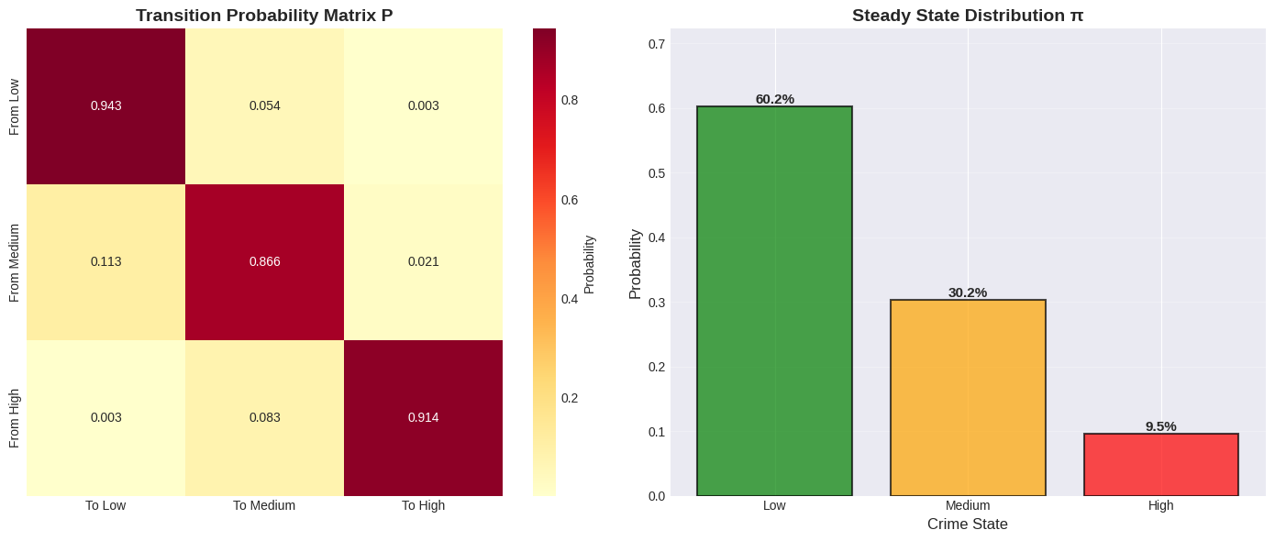
Figure D2.1: Transition Probability Heatmap and steady state distribution chart for District Crime Risk Levels
State Classification Thresholds:
- Low Crime: < 230
- Medium Crime: 230 – 820
- High Crime: > 820
The Markov Chain analysis models year to year transitions between three district crime risk states: Low, Medium, and High. The transition probability matrix exhibits strong diagonal dominance, indicating high persistence across all states. Low-risk districts remain low-risk with a probability of 94.3%, while high-risk districts remain high-risk with a probability of 91.4%, suggesting that crime conditions tend to be stable over time. Medium-risk districts show greater mobility compared to the other states, transitioning to low risk with an 11.3% probability and to high risk with a 2.1% probability. Direct transitions between low and high risk are rare, indicating that crime escalation or reduction typically occurs gradually through the medium-risk state.
The steady-state distribution indicates that, in the long run, approximately 60.2% of districts are expected to be in the low-risk category, 30.2% in the medium-risk category, and 9.5% in the high-risk category indicating a low predominance of high-risk districts. This suggests that while the system is probabilistically stable, a small proportion of districts remains persistently high-risk.
b. Comparison of best, worst and optimum scenarios

- Best-case scenario: Districts remain in or transition toward the low-risk state, which dominates the steady-state distribution (60.2%). This reflects effective crime control and stable safety conditions.
- Worst-case scenario: Districts persist in the high-risk state, which occurs with a high self-transition probability (91.4%), indicating that once high crime levels are reached, they are difficult to reverse without intervention.
- Optimal intervention point: Medium-risk districts represent the most effective target for intervention, as they exhibit the highest transition flexibility and strongly influence long-term system balance.

c. General comparison in terms of:

Perspective | Observation
Individual State Behaviour | - Low and High states are highly stable  - Medium state is most dynamic
State-to-state transitions | - Gradual transitions dominate  - direct Low-High changes are negligible
Short-term vs long-term view | - Short-term persistence leads to long-term dominance of Low and Medium states
Overall system behaviour | - System is stable but not fully self-correcting

E. Conclusion
Method | Type | Key Output | Interpretation
Least Squares | Continuous | Trend: $y = -56130.08x + 113808912.15$ | Crime is decreasing
PCA/SVD | Structural | PC1 explains 100.0% variance | Top 1 PCs explain 90% variance
Dynamic Linear Model | Continuous | Max eigenvalue: 0.901 (STABLE (decaying)) | System is stable
Markov Chain | Probabilistic | High risk steady state: 9.5% | 9.5% of districts will be high-risk long-term

1. Summary of Methodology
This project applied a comparative mathematical approach to analyse crime patterns and stability across Malaysian districts. The methodology integrated four distinct linear algebra and statistical techniques to evaluate the same dataset from different analytical perspectives:
- Least Squares Regression: Used to determine the overall continuous temporal trend of crime data.
- PCA & SVD: Applied to decompose the data structure and identify the principal components driving the variance between crime categories (Assault vs. Property).
- Dynamic Linear Model (DLM): Constructed a discrete dynamical system to evaluate the stability of crime evolution using eigenvalue analysis.
- Markov Chain Analysis: Modelled the probabilistic transitions between crime states (Low, Medium, High) to forecast long-term equilibrium.

2. Results and Insightful Findings
The analysis yielded a highly consistent set of results across all four methodologies, providing strong validation for the conclusions:
- Consistent Downward Trend: The Least Squares Regression revealed a sharp negative slope (y = -56130.08x + 113808912.15), indicating a significant reduction in crime volume over time. This was corroborated by the Dynamic Linear Model, where the maximum eigenvalue of 0.901 (<1) indicated a stable, decaying system. Both models independently confirm that, absent external shocks, crime in these districts is naturally trending downward.
- Structural Uniformity: PCA and SVD analysis showed that 100.0% of the variance is explained by the first principal component. This implies that "Assault" and "Property" crimes are highly correlated and move in tandem, there is no significant divergence where one type increases while the other decreases.
- Long-Term Optimism: The Markov Chain steady-state analysis predicts that in the long run, only 9.5% of districts will remain in the "High Risk" category, while over 60% will stabilize in the "Low Risk" category.
Key Insight: The convergence of the deterministic model (Regression), the dynamical system (DLM), and the probabilistic model (Markov Chain) is the most significant finding. The fact that three different mathematical frameworks all point toward a decrease and decay in crime suggests the trend is robust and not an artifact of a specific calculation method.

3. Recommendations
Based on the findings, the following strategies are recommended for law enforcement and policy planners:
- Targeted vs. Broad Intervention: Since the general trend is decreasing (Stable DLM), broad-spectrum anti-crime policies appear to be working. Resources should now be shifted from general application to the specific 9.5% of districts identified by the Markov Chain as "High Risk" steady states. These districts represent stubborn pockets of crime that resist the general downward trend.
- Resource Reallocation: With 60% of districts projected to be "Low Risk," there is an opportunity to optimize budget allocation. Manpower can be gradually reduced in historically safe districts and concentrated in the Medium Risk zone to prevent them from sliding into High Risk.

4. Future Extension and Study
To enhance the accuracy and depth of this forecasting engine, future studies could include:
- Geospatial Dependency: The current Markov Chain assumes districts are independent. A future extension should incorporate Spatial Markov Chains, considering how crime spills over from a high-risk neighbour to a low-risk neighbour.
- Multivariate Factors: The current model is univariate (based on past crime data). Integrating external variables such as unemployment rates, population density, and police station distribution into the Dynamic Linear Model would allow for "What-If" scenario planning.
- Non-Linear Modeling: While the linear stability analysis (Eigenvalue 0.901) fits the current data well, crime spikes can be sudden. Implementing non-linear dynamical systems or Long Short-Term Memory (LSTM) networks could better capture sudden, chaotic outbreaks of crime that linear models might miss.

F. References
[1] Masseran, N., & Razali, A. M. (2016). Statistical analysis of crime rates in Malaysia. Journal of Fundamental and Applied Sciences, 8(3), 1266-1288.
[2] Department of Statistics Malaysia & Royal Malaysian Police. (2024). Crimes by District & Crime Type (Crime_District) [Dataset]. OpenDOSM. https://open.dosm.gov.my/data-catalogue/crime_district?state=malaysia&district=all&category=assault&type=all&visual=table
[3] Ahmad, N. A., et al. (2024). Demographic dynamics and urban property crime: A linear regression analysis in Kuala Lumpur and Putrajaya (2015-2020). Journal of the Malaysia Institute of Planners, 22(3), 303-314.
[4] Lay, D. C., Lay, S. R., & McDonald, J. J. (2016). Linear Algebra and Its Applications (5th ed.). Pearson.
[5] Strang, G. (2019). Linear Algebra and Learning from Data. Wellesley-Cambridge Press.
[6] Abdi, H., & Williams, L. J. (2010). Principal component analysis. Wiley Interdisciplinary Reviews: Computational Statistics, 2(4), 433-459.
[7] Gyimadu, M., & Bell, G. (2025). A comparative analysis of principal component analysis (PCA) and singular value decomposition (SVD) as dimensionality reduction techniques. arXiv. https://arxiv.org/abs/2506.16663
[8] Shen, Z. (2024). Comparison and evaluation of classical dimensionality reduction methods. Highlights in Science, Engineering and Technology, 70. https://doi.org/10.54097/hset.v70i.13890
[9] Lay, D. C., Lay, S. R., & McDonald, J. J. (2016). Linear Algebra and Its Applications (5th ed.). Pearson. (Chapter 5: Discrete Dynamical Systems).
[10] Stojičić, S., et al. (2025). Advances in Differential Equations and Control Processes, 32(3)
[11] Mann, B. P., & Patel, R. (2010). Proceedings of the Royal Society A, 468
[12] Delbianco, F., Fioriti, A., & Tohmé, F. (2022). Markov chains, eigenvalues and the stability of economic growth processes. Empirical Economics. https://doi.org/10.1007/s00181-022-02276-8
[13] Holloway, S. T. (2023). Assessing State-Dependent Crime Patterns in the USA: A Markov Chain approach. Journal of Information and Technology, 7(1)
[14] Silver, D., & Silva, T. H. (2021). A Markov model of urban evolution: Neighbourhood change as a complex process. PLoS ONE, 16(1), e0245357. https://doi.org/10.1371/journal.pone.0245357
[15] Barros, G. S., & Silva, F. N. (2017). Simultaneous Causality and the Spatial Dynamics of Violent Crimes as a Factor in and Response to Police Patrolling. Information, 8(3), 132. https://www.mdpi.com/2413-8851/8/3/132
[16] Drawve, G., & Grubb, J. (2023). Forecasting crime trends to support police strategic decision making. CrimRxiv. https://www.researchgate.net/publication/371996686_Forecasting_crime_trends_to_support_police_strategic_decision_making

G. Appendix
Data file, Preparation file, Computation & Analysis file, Code file
https://colab.research.google.com/drive/1UUhfe8UI1OvWfnNIukcfhKCFhbvLlfSh?usp=sharing
